Mindfulness for Families
Roanoke City Public Schools
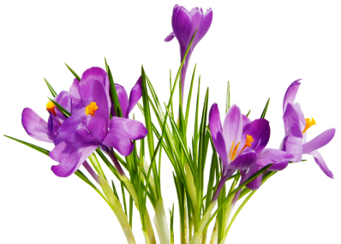

Introduction: The stress of daily life can be challenging, and often we feel rushed; it’s hard to be fully present. We may be distracted by what we’ve left behind or worried about something in the future. As parents, we want to be calm, predictable, and fully present so that we can have strong relationships built on trust. There are times when we need a moment to check in with ourselves, calm our own emotions, and settle so that we can better meet the challenges of parenting.

This is a simple skill called “3 Breaths” that we can use anytime. Practicing this in difficult moments can create a purposeful pause so we can choose what we say or do next (rather than reacting). It’s also helpful when transitioning from one activity to the next (for example, when arriving home after a long, busy day).

3 Breaths is a deep breathing practice, which research has shown helps calm our nervous system, slowing down our heart rate, lowering our blood pressure, and bringing stress hormones back down to baseline. You can practice 3 Breaths while sitting, standing, lying down, or while walking!

3 Breaths Practice Script:

The first step is to Pause. Sit comfortably in a chair, feet on the floor, with your back straight. In a moment we will take a few slow deep breaths. We want the breath to come from our lower abdomen, a deep diaphragmatic breath. When first learning this skill, it can help to place your hand on your abdomen to feel it expand on the inhalation and shrink on the exhalation.

Now I invite you to take 3 or 4 deep breaths at your own pace; breathe in deeply, then breathe out very slowly. Take a few moments now to take these deep, calming breaths. Notice the sensation of air as it goes in and out of your body, calming your body. When you’re finished the deep breaths, just breathe at your normal pace.

To end: Now take a moment to thank yourself for taking this time for self-care. You may want to gently move and stretch your body, and slowly transition back into your day.

